Graphs and Graph Algorithms

A graph is simply a set of points together with a set of lines connecting various points. Myriad real-world application problems can be reduced to problems on graphs.
Suppose you are planning a trip by airplane. From a map you have determined the distances between the airports in the various cities that you wish to visit. The information you have gathered can be represented using a graph as shown in Figure (a). The points in the graph represent the cities and the lines represent the distances between them. Given such a graph, you can answer questions such as ``What is the shortest distance between LAX and JFK?'' or ``What is the shortest route that visits all of the cities?''
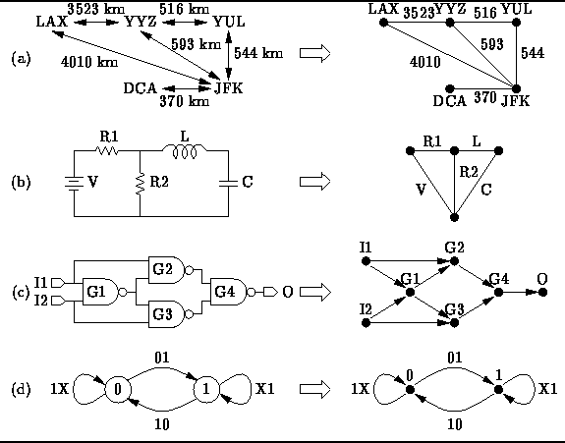
Figure: Real-World Examples of Graphs
An electric circuit can also be viewed as a graph as shown in Figure (b). In this case the points in the graph indicate where the components are connected (i.e., the wires) and the lines represent the components themselves (e.g, resistors and capacitors). Given such a graph, we can answer questions such as ``What are the mesh equations that describe the circuit's behavior?''
Similarly, a logic circuit can be reduced to a graph as shown in Figure (c). In this case the logic gates are represented by the points and arrows represent the signal flows from gate outputs to gate inputs. Given such a graph, we can answer questions such as “How long does it take for the signals to propagate from the inputs to the outputs?”' or “Which gates are on the critical path?”
Finally, Figure (d) illustrates that a graph can be used to represent a finite state machine. The points of the graph represent the states and labeled arrows indicate the allowable state transitions. Given such a graph, we can answer questions such as “Are all the states reachable?” or “Can the finite state machine deadlock?”
This chapter is a brief introduction to the body of knowledge known as graph theory . It covers the most common data structures for the representation of graphs and introduces some fundamental graph algorithms.
- Basics
- Implementing Graphs
- Graph Traversals
- Shortest-Path Algorithms
- Minimum-Cost Spanning Trees
- Application: Critical Path Analysis
- Exercises
- Projects

Basics
- Directed Graphs
- Terminology
- More Terminology
- Directed Acyclic Graphs
- Undirected Graphs
- Terminology
- Labeled Graphs
- Representing Graphs

Directed Graphs
We begin with the definition of a directed graph:
Definition (Directed Graph) A directed graph , or digraph , is an ordered pair G = {V, E} with the following properties:
- The first component, , is a finite, non-empty set. The elements of are called the vertices of G.
- The second component, , is a finite set of ordered pairs of vertices. I.e., . The elements of are called the edges of G.
For example, consider the directed graph comprised of four vertices and six edges:
The graph G can be represented graphically as shown in Figure . The vertices are represented by appropriately labeled circles, and the edges are represented by arrows that connect associated vertices.
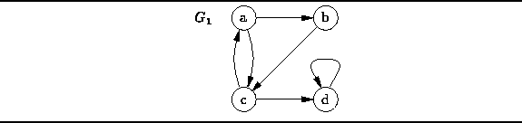
Figure: A Directed Graph
Notice that because the pairs that represent edges are ordered, the two edges (a,c) and (c,a) are distinct. Furthermore, since is a mathematical set, it cannot contain more than one instance of a given edge. And finally, an edge such as (d,d) may connect a node to itself.

Terminology
Consider a directed graph as given by Definition .
- Each element of is called a vertex or a node of G. Hence, is the set of vertices (or nodes) of G.
- Each element of is called an edge or an arc of G. Hence, is the set of edges (or arcs) of G.
- An edge can be represented as . An arrow that points from v to w is known as a directed arc . Vertex w is called the head of the arc because it is found at the arrow head. Conversely, v is called the tail of the arc. Finally, vertex w is said to be adjacent to vertex v.
- An edge e=(v,w) is said to emanate from vertex v. We use notation to denote the set of edges emanating from vertex v. I.e.,
- The out-degree of a node is the number of edges emanating from that node. Therefore, the out-degree of v is
- An edge e=(v,w) is said to be incident on vertex w. We use notation to denote the set of edges incident on vertex w. I.e.,
- The in-degree of a node is the number of edges incident on that node. Therefore, the in-degree of w is
For example, Table enumerates the sets of emanating and incident edges and the in- and out-degrees for each of the vertices in graph shown in Figure .

vertex v |  | out-degree |  | in-degree
a |  | 2 |  | 1
b |  | 1 |  | 1
c |  | 2 |  | 2
d |  | 1 |  | 2
Table: Emanating and Incident Edge Sets for Graph in Figure
There is still more terminology to be introduced, but in order to do that, we need the following definition:
Definition (Path and Path Length)
A path in a directed graph is a non-empty sequence of vertices
where for such that for . The length of path P is k-1.
For example, consider again the graph shown in Figure . Among the paths contained in there is the path of length zero, ; the path of length one, ; the path of length two, ; and so on. In fact, this graph generates an infinite number of paths! (To see how this is possible, consider that is a path in ). Notice too the subtle distinction between a path of length zero, say , and the path of length one .

More Terminology
Consider the path in a directed graph .
- Vertex is the successor of vertex for . Each element of path P (except the last) has a successor.
- Vertex is the predecessor of vertex for . Each element of path P (except the first) has a predecessor.
- A path P is called a simple path if and only if for all i and j such that . However, it is permissible for to be the same as in a simple path.
- A cycle is a path P of non-zero length in which . The length of a cycle is just the length of the path P.
- A loop is a cycle of length one. I.e., it is a path of the form .
- A simple cycle is a path that is both a cycle and simple.
Referring again to graph in Figure we find that the path is a simple path of length three. Conversely, the path also has length three but is not simple because vertex c occurs twice in the sequence (but not at the ends). The graph contains the path which is a cycle of length three, as well as , a cycle of length four. The former is a simple cycle but the latter is not.

Directed Acyclic Graphs
For certain applications it is convenient to deal with graphs that contain no cycles. For example, a tree (see Chapter ) is a special kind of graph that contains no cycles.
Definition (Directed Acyclic Graph (DAG))
A directed, acyclic graph is a directed graph that contains no cycles.
Obviously, all trees are DAGs. However, not all DAGs are trees. For example consider the two directed, acyclic graphs, and , shown in Figure . Clearly is a tree but is not.
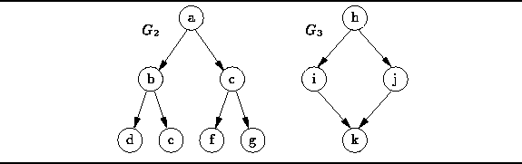
Figure: Two Directed, Acyclic Graphs

Undirected Graphs
An undirected graph is a graph in which the nodes are connected by undirected arcs . An undirected arc is an edge that has no arrow. Both ends of an undirected arc are equivalent--there is no head or tail. Therefore, we represent an edge in an undirected graph as a set rather than an ordered pair:
Definition (Undirected Graph) An undirected graph is an ordered pair with the following properties:
- The first component, , is a finite, non-empty set. The elements of are called the vertices of G.
- The second component, , is a finite set of sets. Each element of is a set that is comprised of exactly two (distinct) vertices. The elements of are called the edges of G.
For example, consider the undirected graph comprised of four vertices and four edges:
The graph can be represented graphically as shown in Figure . The vertices are represented by appropriately labeled circles, and the edges are represented by lines that connect associated vertices.
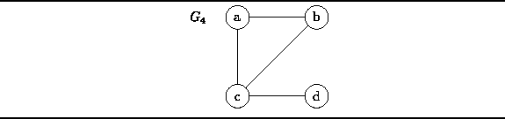
Figure: An Undirected Graph
Notice that because an edge in an undirected graph is a set, , and since is also a set, it cannot contain more than one instance of a given edge. Another consequence of Definition is that there cannot be an edge from a node to itself in an undirected graph because an edge is a set of size two and a set cannot contain duplicates.

Terminology
Consider an undirected graph as given by Definition .
- An edge emanates from and is incident on both vertices v and w.
- The set of edges emanating from a vertex v is the set The set of edges incident on a vertex w is .
Practical applications of graphs usually require that they be annotated with additional information. Such information may be attached to the edges of the graph and to the nodes of the graph. A graph which has been annotated in some way is called a labeled graph . Figure shows two examples of this.
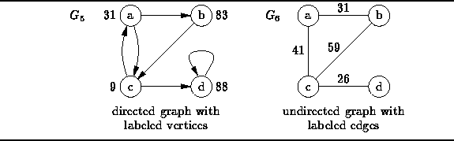
Figure: Labeled Graphs
For example, we can use a directed graph with labeled vertices such as in Figure to represent a finite state machine. Each vertex corresponds to a state of the machine and each edge corresponds to an allowable state transition. In such a graph we can attach a label to each vertex that records some property of the corresponding state such as the latency time for that state.
We can use an undirected graph with labeled edges such as in Figure to represent geographic information. In such a graph, the vertices represent geographic locations and the edges represent possible routes between locations. In such a graph we might use a label on each edge to represent the distance between the end points.

Representing Graphs
Consider a directed graph . Since , graph G contains at most edges. There are possible sets of edges for a given set of vertices . Therefore, the main concern when designing a graph representation scheme is to find a suitable way to represent the set of edges.

Implementing Graphs
In keeping with the design framework used throughout this text, we view graphs as specialized containers. Formally, the graph is an ordered pair comprised of two sets--a set of vertices and a set of edges. Informally, we can view a graph as a container with two compartments, one which holds vertices and one which holds edges. Therefore, there are three kinds of objects--vertices, edges, and graphs. Accordingly, we need three object classes: Vertex, Edge, and Graph. (See Figure ).
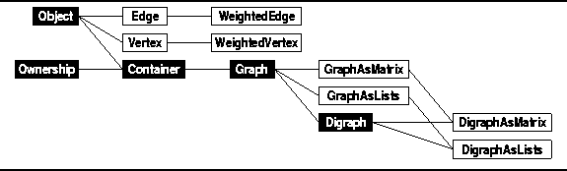
Figure: Object Class Hierarchy
- Implementing Vertices
- Implementing Edges
- Abstract Graphs and Digraphs
- Implementing Undirected Graphs
- Edge-Weighted and Vertex-Weighted Graphs
- Comparison of Graph Representations

Implementing Vertices
What exactly is a vertex? The answer to this question depends on the application. At the very minimum, every vertex in a graph must be distinguishable from every other vertex in that graph. We can do this by numbering consecutively the vertices of a graph.
Program defines the concrete class Vertex. Since we intend to insert instances of this class into containers, the Vertex class is derived from the Object base class. The Vertex class declares a single member the single member variable number. Each vertex inserted into a graph is required to have a different number.
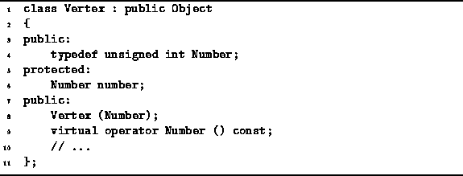
Program: Vertex Class Definition
A single Vertex constructor is declared. This constructor takes as its lone argument the number that is to be assigned to the vertex. In addition, the cast-to-Number member function (operator Number) is also declared. This allows the programmer to use a vertex wherever an integer is expected. The cast returns the value of the number member variable.

Implementing Edges
An edge in a directed graph is an ordered pair of vertices; an edge in an undirected graph is a set of two vertices. Because of the similarity of these concepts, we use the same class for both--the context in which an edge is used determines whether it is directed or undirected.
Program declares the concrete class Edge. Since we intend to insert instances of this class into containers, the Edge class is derived from the Object base class.
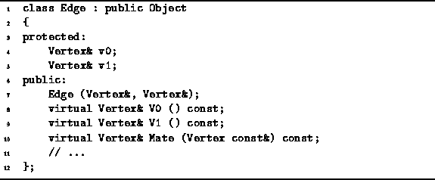
Program: Edge Class Definition
The Edge class contains two member variables--v0 and v1. Each is a reference to a vertex. When an instance of this class is used to represent a directed edge, then the edge represented shall be . I.e., v1 is the head and v0 is the tail. Alternatively, when an Edge instance represents an undirected edge, that edge is simply .
Program declares a constructor which takes two arguments, both of them references to Vertex instances. The effect of this constructor is to initialize the two corresponding member variables accordingly.
In addition to the constructor, there are three public member functions: V0, V1 and Mate. All three of them are accessors. The first are used to access the member variables v0 and v1, respectively.
For every instance e of the Edge class, the Mate member function satisfies the following identities:
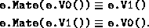
Therefore, if we know that a vertex v is one of the vertices of e, then we can find the other vertex by calling e.Mate(v).

Abstract Graphs and Digraphs
Directed graphs and undirected graphs have many common characteristics. Therefore, it seems reasonable to make use of inheritance in the implementation of graph classes. However, there are several possible ways in which to organize the class hierarchy:
Option A
We could use a common abstract base class Graph to encapsulate the common attributes of all graphs and then derive two different classes UndirectedGraph and DirectedGraph from the common base class.
Option B
Use DirectedGraph as the base class and derive the class UndirectedGraph from it. In this scenario we view an undirected graph as a directed graph that has its arrows removed.
Option C
Use UndirectedGraph as the base class and derive the class DirectedGraph from it. In this scenario we view a directed graph as an undirected graph with arrows added.
As shown in Figure , we have chosen to use option C. We have chosen this approach because many algorithms for undirected graphs can also be used with directed graphs. On the other hand, it is often the case that algorithms for directed graphs cannot be used with undirected graphs.
Program declares two abstract classes, Graph and Digraph. The Graph class is the base class from which concrete classes that represent undirected graphs are derived. The Digraph abstract class extends the Graph class. The Digraph class is the base class from which concrete classes that represent directed graphs are derived.
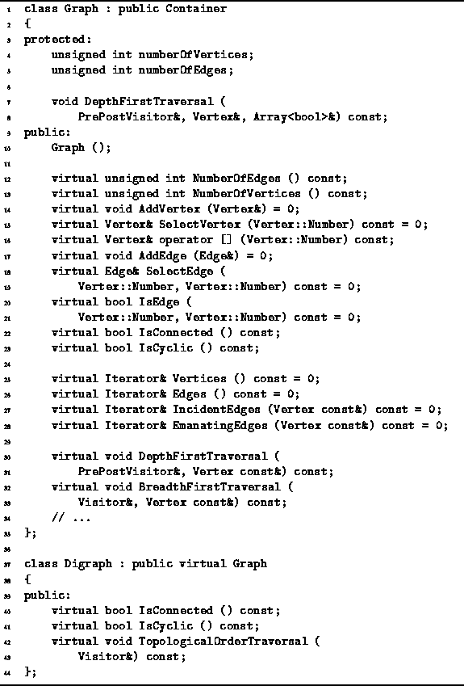
Program: Graph and Digraph Class Definitions
The Graph class is an abstract base class since it contains pure virtual member functions. The graph class adds two member variables to those inherited from the base classes--numberOfEdges and numberOfVertices. A default constructor for the Graph class is also declared. The effect of this constructor is to initialize both member variables with the value zero. Therefore, a graph is initially empty--it contains neither vertices nor edges.
A number of Graph class member functions are declared in Program . There are essentially three groups of member functions: accessors and mutators, iterators, and traversals. The operations performed by the member functions are explained in the following sections.
- Accessors and Mutators
- Iterators
- Graph Traversals

Accessors and Mutators
The Graph class declares the following accessor and mutator member functions:
NumberOfEdges
This accessor returns the number of edges contained by the graph.
NumberOfVertices
This accessor returns the number of vertices contained by the graph.
AddVertex
This mutator inserts a given vertex into a graph. For simplicity, we shall assume that a given vertex is inserted into exactly one graph. All the vertices contained in a given graph must have a unique vertex number. Furthermore, if a graph contains n vertices, those vertices shall be numbered 0, 1, ..., n-1. Therefore, the next vertex inserted into the graph shall have the number n.
SelectVertex
This accessor takes an integer, say i where , and returns reference to the vertex contained in the graph.
operator[]
This subscript operator takes an integer-valued subscript expression. We shall assume that the default behavior of this operator is to call SelectVertex.
AddEdge
This mutator inserts a given edge into a graph. For simplicity, we shall assume that a given edge is inserted into exactly one graph. Both vertices referenced by the edge must be vertices in the given graph.
IsEdge
This Boolean-valued accessor takes two Vertex::Number arguments. It returns true if the graph contains an edge that connects the corresponding vertices.
SelectEdge
This accessor takes two Vertex::Number arguments. It returns a reference to the edge instance (if it exists) that connects the corresponding vertices. The behavior of this routine is undefined when the edge does not exist. (An implementation will typically throw an exception).
IsCyclic
This Boolean-valued accessor returns true if the graph is cyclic.
IsConnected
This Boolean-valued accessor returns true if the graph is connected. Connectedness of graphs is discussed in Section .

Iterators
All the other container classes considered in this text have only one associated iterator. When dealing with graphs, it is convenient to have at least four iterators: The first two are used to enumerate the sets and , and the last two are used to enumerate the sets and associated with a given vertex v.
Each of the following member functions allocates dynamically a new iterator instance as follows:
Vertices
This member function of the Graph class returns an iterator that can be used to traverse the elements of .
Edges
This member function of the Graph class returns an iterator that can be used to traverse the elements of .
IncidentEdges
This member function takes a reference to a vertex, say v, and returns an iterator that can be used to traverse the elements of . The vertex v must be contained by the graph.
EmanatingEdges
This member function takes a reference to a vertex, say v, and returns an iterator that can be used to traverse the elements of . The vertex v must be contained by the graph.

Graph Traversals
These graph traversal functions are analogous to the Accept member function of the container class (see Section ). Each of these functions takes a reference to a Visitor and performs a traversal. I.e., all the vertices of the graph are visited systematically. When a vertex is visited, the Visit function of the visitor is applied to that vertex.
DepthFirstTraversal and BreadthFirstTraversal
Both of these functions accept two arguments--a reference to a Visitor and a reference to a vertex. The vertex specifies the starting node for either a depth-first traversal or a breadth-first traversal of the graph.
TopologicalOrderTraversal
A topological sort is an ordering of the nodes of a directed graph. This traversal visits the nodes of a directed graph in the order specified by a topological sort. Therefore, it is a member function of the Digraph class.
The graph traversal algorithms are discussed in Section .

Implementing Undirected Graphs
This section describes two concrete classes--GraphAsMatrix and GraphAsLists. These classes both represent undirected graphs. The GraphAsMatrix class represents the edges of a graph using an adjacency matrix. The GraphAsLists class represents the edges of a graph using adjacency lists.
- Using Adjacency Matrices
- Using Adjacency Lists

Using Adjacency Matrices
The GraphAsMatrix class is declared in Program . The GraphAsMatrix class is a concrete class derived from the base class Graph which is shown in Program . Since GraphAsMatrix is a concrete class, it must provide implementations for all the member functions declared as pure virtual functions in the base classes--the function prototypes have been elided for the sake of brevity.
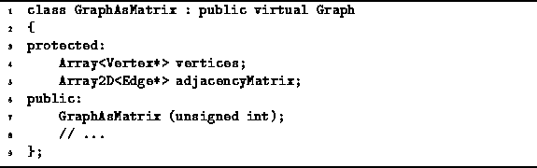
Program: GraphAsMatrix Class Definition
Each instance of the GraphAsMatrix class represents an undirected graph, say . The two member variables, vertices and adjacencyMatrix, are used to represent the sets and , respectively.
The set of vertices, , is represented using a one-dimensional array of pointers to Vertex instances. The implementation uses the Array<T> class given in Section . The set of edges, , is represented using a two-dimensional matrix of pointers to Edge instances. The implementation uses the Array2D<T> class given in Section .
The GraphAsMatrix constructor takes a single argument of type unsigned int that specifies the maximum number of vertices that the graph may contain. This quantity specifies the length of the array of vertices and the dimensions of the adjacency matrix. The implementation of the GraphAsMatrix class is left as programming project for the reader (Project ).

Using Adjacency Lists
Program declares the GraphAsLists concrete class. The GraphAsLists class is derived from the abstract base class Graph. The GraphAsLists class represents the edges of a graph using adjacency lists.
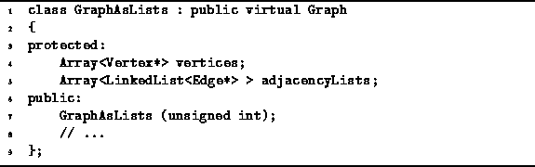
Program: GraphAsLists Class Definition
Two member variables are declared--vertices and adjacencyLists. The former is an array of pointers to Vertex instances. This array is used to represent the elements of the vertex set .
The second member variable is an array of linked lists of pointers to edges. The linked list, adjacencyLists[i], represents the set which is the set of edges emanating from vertex . The implementation uses the LinkedList<T> class given in Section .
The GraphAsLists constructor takes a single argument of type unsigned int that specifies the maximum number of vertices that the graph may contain. This quantity specifies the lengths of the array of vertices and the array of adjacency lists. The implementation of the GraphAsLists class is left as programming project for the reader (Project ).

Edge-Weighted and Vertex-Weighted Graphs
An edge-weighted graph is a graph in which each edge has been assigned a weight. Similarly, a vertex-weighted graph is a graph in which each vertex has been assigned a weight. In such graphs, the quantity represented by a weight depends on the application.
Since a graph is a container that contains specifically vertices and edges, it is not necessary to introduce new graph classes to represent edge-weighted and vertex-weighted graphs. Instead, we introduce two classes, WeightedVertex and WeightedEdge. By using instances of these new classes together with the existing graph classes, we can create arbitrary edge-weighted and vertex-weighted graphs. Program contains the declarations of the WeightedVertex and WeightedEdge classes.
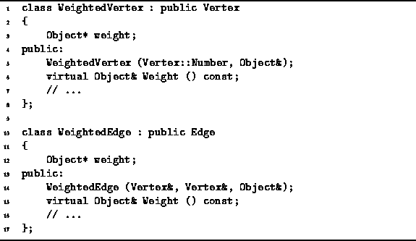
Program: WeightedVertex and WeightedEdge Class Definitions
Since the WeightedVertex class is derived from the Vertex class, instances of the former can be used wherever the latter is expected. Therefore, we can create a vertex-weighted graph simply by inserting weighted vertices into an instance of one of the graph implementations discussed in the preceding section.
The WeightedVertex<T> class contains a single member variable called weight which is a pointer to an Object instance. Therefore, any object type can be used as the weight. The constructor sets the weight to a given value, and the member function Weight is used to access the weight.
The WeightedEdge<T> class is implemented similarly. I.e., weighted edge instances can be used wherever an edge is expected. By inserting weighted edges into a graph, we get an edge-weighted graph. Clearly, if the application demands it, it is possible to use both weighted vertices and weighted edges in the same graph

Comparison of Graph Representations
In order to make the appropriate choice when selecting a graph representation scheme, it is necessary to understand the time/space trade-offs. Although the details of the implementations have been omitted, we can still make meaningful conclusions about the performance that we can expect from those implementations. In this section we consider the space required as well as the running times for basic graph operations.
- Space Comparison
- Time Comparison

Space Comparison
Consider the representation of a directed graph . In addition to the Vertex class instances and the Edge class instances contained by the graph, there is the storage required by the adjacency matrix. In this case, the matrix is a matrix of pointers to Edge instances. Therefore, the amount of storage required by an adjacency matrix implementation is
On the other hand, consider the amount of storage required when we represent the same graph using adjacency lists. In addition to the vertices and the edges themselves, there are linked lists. If we use the LinkedList class defined in Section , each such list has a head and tail pointer. Altogether there are linked lists elements, each of which consists of a pointer to the next element of the lists and a pointer to an edge. Therefore, the total space required is
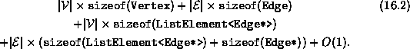
Notice that the space for the vertices and edges themselves cancels out when we compare Equation with Equation . If we assume that all pointers require the same amount of space, we can conclude that adjacency lists use less space than adjacency matrices when
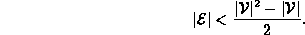
For example, given a 10 node graph, the adjacency lists version uses less space when there are fewer than 45 edges. As a rough rule of thumb, we can say that adjacency lists use less space when the average degree of a node, , satisfies .

Time Comparison
The following four operations are used extensively in the implementations of many different graph algorithms:
find edge (v,w)
Given vertices v and w, this operation locates the corresponding Edge instance. When using an adjacency matrix, we can find an edge in constant time.
When adjacency lists are used, the worst-case running time is , since is the length of the adjacency list associated with vertex v.
This is the operation performed by the SelectEdge member function of the Graph class.
enumerate all edges
In order to locate all the edges in when using adjacency matrices, it is necessary to examine all matrix entries. Therefore, the worst-case running time needed to enumerate all the edges is .
On the other hand, to enumerate all the edges when using adjacency lists requires the traversal of lists. In all there are edges. Therefore the worst case running time is .
This operation is performed using the iterator returned by the Edges member function of the Graph class.
enumerate edges emanating from v
To enumerate all the edges that emanate from vertex v requires a complete scan of the row of an adjacency matrix. Therefore, the worst-case running time when using adjacency matrices is .
Enumerating the edges emanating from vertex v is a trivial operation when using adjacency lists. All we need do is traverse the list. This takes time in the worst case.
This operation is performed using the iterator returned by the EmanatingEdges member function of the Graph class.
enumerate edges incident on w
To enumerate all the edges are incident on vertex w requires a complete scan of the column of an adjacency matrix. Therefore, the worst-case running time when using adjacency matrices is .
Enumerating the edges incident on vertex w is a non-trivial operation when using adjacency lists. It is necessary to search every adjacency list in order to find all the edges incident on a given vertex. Therefore, the worst-case running time is .
This operation is performed using the iterator returned by the IncidentEdges member function of the Graph class.
Table summarizes these running times.
 | representation scheme
operation | adjacency matrix | adjacency list
find edge (v,w) | O(1)
enumerate all edges
enumerate edges emanating from v
enumerate edges incident on w
Table: Comparison of Graph Representations

Graph Traversals

There are many different applications of graphs. As a result, there are many different algorithms for manipulating them. However, many of the different graph algorithms have in common the characteristic that they systematically visit all the vertices in the graph. I.e., the algorithm walks through the graph data structure and performs some computation at each vertex in the graph. This process of walking through the graph is called a graph traversal .
While there are many different possible ways in which to systematically visit all the vertices of a graph, certain traversal methods occur frequently enough that they are given names of their own. This section presents three of them--depth-first traversal, breadth-first traversal and topological sort.
- Depth-First Traversal
- Breadth-First Traversal
- Topological Sort
- Graph Traversal Applications:
Testing for Cycles and Connectedness

Depth-First Traversal
The depth-first traversal of a graph is like the depth-first traversal of a tree discussed in Section . A depth-first traversal of a tree always starts at the root of the tree. Since a graph has no root, when we do a depth-first traversal, we must specify the vertex at which to begin.
A depth-first traversal of a tree visits a node and then recursively visits the subtrees of that node. Similarly, depth-first traversal of a graph visits a vertex and then recursively visits all the vertices adjacent to that node. The catch is that the graph may contain cycles, but the traversal must visit every vertex at most once. The solution to the problem is to keep track of the nodes that have been visited, so that the traversal does not suffer the fate of infinite recursion.
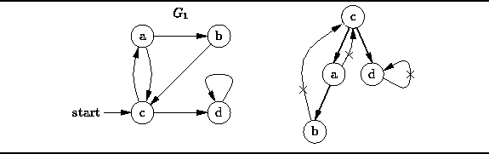
Figure: Depth-First Traversal
For example, Figure illustrates the depth-first traversal of the directed graph starting from vertex c. The depth-first traversal visits the nodes in the order
A depth-first traversal only follows edges that lead to unvisited vertices. As shown in Figure , if we omit the edges that are not followed, the remaining edges form a tree. Clearly, the depth-first traversal of this tree is equivalent to the depth-first traversal of the graph
- Implementation
- Running Time Analysis

Implementation
Program gives the code for the two DepthFirstTraversal routines of the Graph class. One of them accepts two arguments, the other, three. As indicated in Program , the two-argument routine is declared public whereas the three-argument one is protected.
The user of the Graph class only sees the two-argument DepthFirstTraversal routine. This routine takes a reference to a Visitor instance and a reference to a Vertex instance. The idea is that the Visit function of the visitor is called once for each vertex in the graph and the vertices are visited in depth-first traversal order starting from the specified vertex.

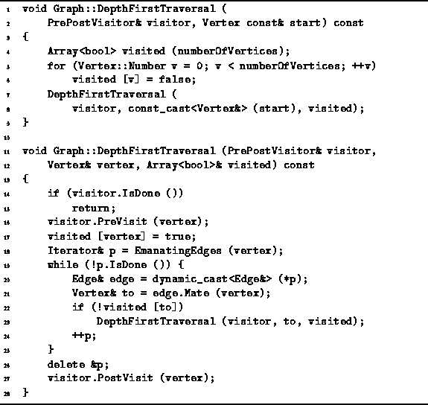
Program: Graph Class DepthFirstTraversal Member Function Definition
In order to ensure that each vertex is visited at most once, an array of length of Boolean values called visited is used (line 4). I.e., only if vertex i has been visited. All the array elements are initially false (lines 5-6). After initializing the array, the two-argument routine calls the three-argument one, passing it a reference to the array as the third argument.
The three-argument routine returns immediately if the visitor is done. Otherwise, it visits the specified node, and then it follows all the edges emanating from that node and recursively visits the adjacent vertices if those vertices have not already been visited.

Running Time Analysis
The running time of the depth-first traversal routine depends on the graph representation scheme used. The traversal visits each node in the graph at most once. When a node is visited, all the edges emanating from that node are considered. During a complete traversal enumerates every edge in the graph.
Therefore, the worst-case running time for the depth-first traversal of a graph is represented using an adjacency matrix is
When adjacency lists are used, the worst case running time for the depth-first traversal routine is
Recall that for a sparse graph graph . If the sparse graph is represented using adjacency lists and if and the worst-case running time of the depth-first traversal is simply .

Breadth-First Traversal
The breadth-first traversal of a graph is like the breadth-first traversal of a tree discussed in Section . The breadth-first traversal of a tree visits the nodes in the order of their depth in the tree. Breadth-first tree traversal first visits all the nodes at depth zero (i.e., the root), then all the nodes at depth one, and so on.
Since a graph has no root, when we do a breadth-first traversal, we must specify the vertex at which to start the traversal. Furthermore, we can define the depth of a given vertex to be the length of the shortest path from the starting vertex to the given vertex. Thus, breadth-first traversal first visits the starting vertex, then all the vertices adjacent to the starting vertex, and the all the vertices adjacent to those, and so on.
Section presents a non-recursive breadth-first traversal algorithm for N-ary trees that uses a queue to keep track vertices that need to be visited. The breadth-first graph traversal algorithm is very similar.
First, the starting vertex is enqueued. Then, the following steps are repeated until the queue is empty:
- Remove the vertex at the head of the queue and call it vertex.
- Visit vertex.
- Follow each edge emanating from vertex to find the adjacent vertex and call it to. If to has not already been put into the queue, enqueue it.
Notice that a vertex can be put into the queue at most once. Therefore, the algorithm must somehow keep track of the vertices that have been enqueued.
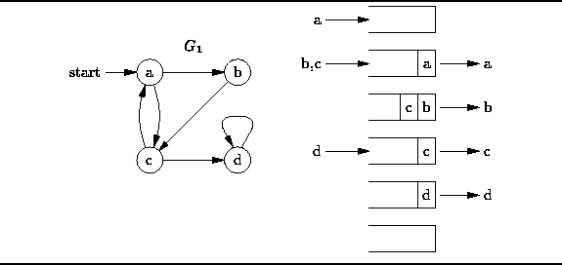
Figure: Breadth-First Traversal
Figure illustrates the breadth-first traversal of the directed graph starting from vertex a. The algorithm begins by inserting the starting vertex, a, into the empty queue. Next, the head of the queue (vertex a) is dequeued and visited, and the vertices adjacent to it (vertices b and c) are enqueued. When, b is dequeued and visited we find that there is only adjacent vertex, c, and that vertex is already in the queue. Next vertex c is dequeued and visited. Vertex c is adjacent to a and d. Since a has already been enqueued (and subsequently dequeued) only vertex d is put into the queue. Finally, vertex d is dequeued an visited. Therefore, the breadth-first traversal of starting from a visits the vertices in the sequence
- Implementation
- Running Time Analysis

Implementation
Program gives the code for the BreadthFirstTraversal routine of the Graph class. This routine takes a reference to a Visitor instance and a reference to a Vertex instance. The Visit function of the visitor is called once for each vertex in the graph and the vertices are visited in breadth-first traversal order starting from the specified vertex.
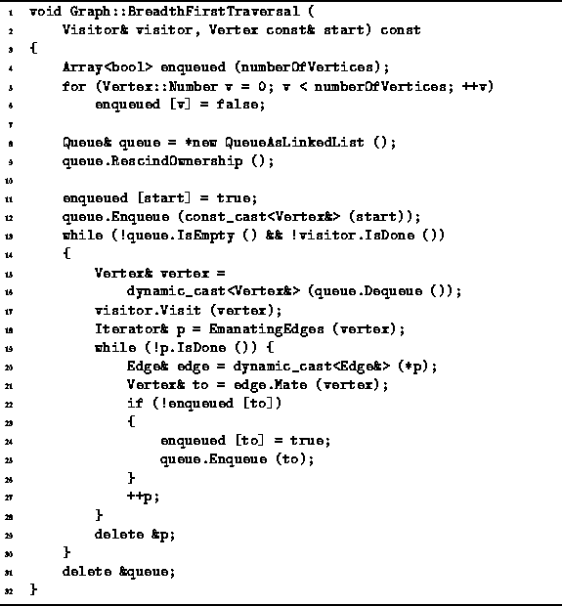
Program: Graph Class BreadthFirstTraversal Member Function Definition
An Boolean-valued array, enqueued, is used to keep track of the vertices that have been put into the queue. The elements of the array are all initialized to false (lines 4-6).
Next, a new queue instance is allocated dynamically (line 8). The queue is used to contain only vertices. Since the vertices are owned by the graph, they cannot also be owned by the queue. Therefore, the RescindOwnership function of the queue is called (line 9). This way, when the queue destructor is called, it will not attempt to delete any of the its contained objects.
The second argument of the BreadthOrderTraversal function is a reference to a const vertex. Therefore, the routine must not modify the start vertex. However, we need to push the vertex onto the queue and since the Enqueue function takes a non-const Object reference, it is necessary to cast away the constness using a constcast (line 12). This is not an unsafe cast in this context, because the queue is a local variable of the BreadthOrderTraversal routine and because the routine does not modify anything which it later dequeues from the queue.
The main loop of the BreadthFirstTraversal routine comprises lines 13-30. This loop continues as long as there is a vertex in the queue and the visitor is willing to do more work (line 13). In each iteration exactly one vertex is dequeued and visited (lines 15-17). After a vertex is visited, all the successors of that node are examined (lines 18-21). Every successor of the node that has not yet been enqueued is put into the queue and the fact that it has been enqueued is recored in the array enqueued (lines 22-26).

Running Time Analysis
The breadth-first traversal enqueues each node in the graph at most once. When a node is dequeued, all the edges emanating from that node are considered. Therefore, a complete traversal enumerates every edge in the graph.
The actual running time of the breadth-first traversal routine depends on the graph representation scheme used. The worst-case running time for the traversal of a graph represented using an adjacency matrix is
When adjacency lists are used, the worst case running time for the breadth-first traversal routine is
If the graph is sparse, then . Therefore, if a sparse graph is represented using adjacency lists and if , the worst-case running time of the breadth-first traversal is just .

Topological Sort

A topological sort is an ordering of the vertices of a directed acyclic graph given by the following definition:
Definition (Topological Sort) Consider a directed acyclic graph . A topological sort of the vertices of G is a sequence in which each element of appears exactly once. For every pair of distinct vertices and in the sequence S, if is an edge in G, i.e., , then i<j.
Informally, a topological sort is a list of the vertices of a DAG in which all the successors of any given vertex appear in the sequence after that vertex. Consider the directed acyclic graph shown in Figure . The sequence is a topological sort of the vertices of . To see that this is so, consider the set of vertices:
The vertices in each edge are in alphabetical order, and so is the sequence S.
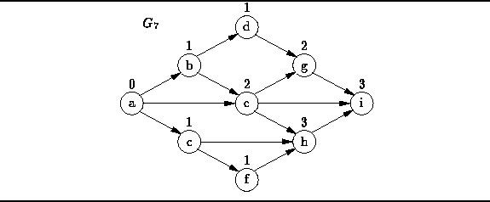
Figure: A Directed Acyclic Graph
It should also be evident from Figure that a topological sort is not unique. For example, the following are also valid topological sorts of the graph :
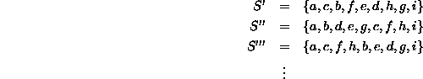
One way to find a topological sort is to consider the in-degrees of the vertices. (The number above a vertex in Figure is the in-degree of that vertex). Clearly the first vertex in a topological sort must have in-degree zero and every DAG must contain at least one vertex with in-degree zero. A simple algorithm to create the sort goes like this:
Repeat the following steps until the graph is empty:
- Select a vertex that has in-degree zero.
- Add the vertex to the sort.
- Delete the vertex and all the edges emanating from it from the graph.
- Implementation
- Running Time Analysis

Implementation
Instead of implementing an algorithm that computes a topological sort, we have chosen to implement a traversal that visits the vertices of a DAG in the order given by the topological sort. The topological order traversal can be used to implement many other graph algorithms. Furthermore, given such a traversal, it is easy to define a visitor that computes a topological sort.
In order to implement the algorithm described in the preceding section, an array of integers of length is used to record the in-degrees of the vertices. As a result, it is not really necessary to remove vertices or edges from the graph during the traversal. Instead, the effect of removing a vertex and all the edges emanating from that vertex is simulated by decreasing the apparent in-degrees of all the successors of the removed vertex.
In addition, we use a queue to keep track of the vertices that have not yet been visited, but whose in-degree is zero. Doing so eliminates the need to search the array for zero entries.
Program defines the TopologicalOrderTraversal routine of the Digraph class. This routine takes as its lone argument a reference to a visitor instance. The Visit function of the visitor is called once for each vertex in the graph. The order in which the vertices are visited is given by a topological sort of those vertices.
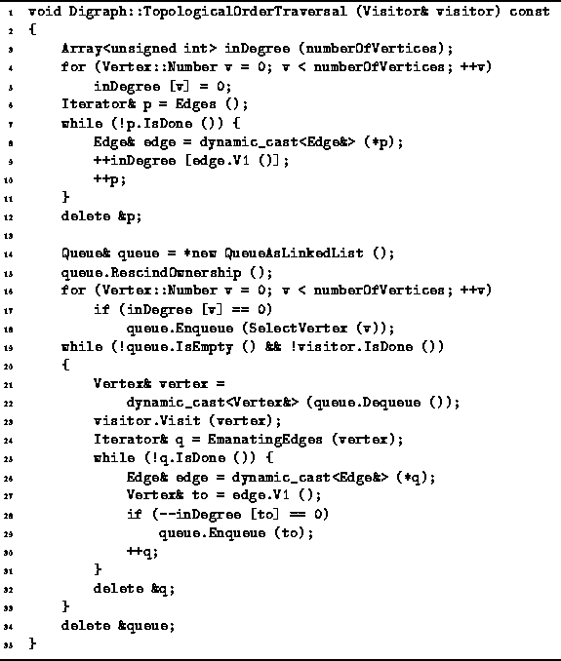
Program: Digraph Class TopologicalOrderTraversal Member Function Definition
The algorithm begins by computing the in-degrees of all the vertices. An array of unsigned integers of length called inDegree is used for this purpose. First, all the array elements are set to zero. Then, for each edge , array element is increased by one (lines 3-12).
Next, a queue to hold vertices is created. Since the vertices are owned by the graph, the RescindOwnership member function of the queue is called. That way, the queue will not attempt to delete any contained vertices when its destructor is called. After the queue has been initialized, all vertices with in-degree zero are enqueued (lines 14-18).
The main loop of the TopologicalOrderTraversal routine comprises lines 19-33. This loop continues as long as the queue is not empty and the visitor is not finished. In each iteration of the main loop exactly one vertex is dequeued and visited (lines 21-23).
Once a vertex has been visited, the effect of removing that vertex from the graph is simulated by decreasing by one the in-degrees of all the successors of that vertex. When the in-degree of a vertex becomes zero, that vertex is enqueued (lines 24-30).

Running Time Analysis
The topological-order traversal enqueues each node in the graph at most once. When a node is dequeued, all the edges emanating from that node are considered. Therefore, a complete traversal enumerates every edge in the graph.
The worst-case running time for the traversal of a graph represented using an adjacency matrix is
When adjacency lists are used, the worst case running time for the topological-order traversal routine is

Graph Traversal Applications:
Testing for Cycles and Connectedness

This section presents several graph algorithms that are based on graph traversals. The first two algorithms test undirected and directed graphs for connectedness. Both algorithms are implemented using the depth-first traversal. The third algorithm tests a directed graph for cycles. It is implemented using a topological-order traversal.
- Connectedness of an Undirected Graph
- Connectedness of a Directed Graph
- Testing for Cycles in a Directed Graph

Connectedness of an Undirected Graph
Definition (Connectedness of an Undirected Graph) An undirected graph is connected if there is a path in G between every pair of vertices in .
Consider the undirected graph shown in Figure . It is tempting to interpret this figure as a picture of two graphs. However, the figure actually represents the undirected graph , given by
Clearly, the graph is not connected. For example, there is no path between vertices a and d. In fact, the graph consists of two, unconnected parts, each of which is a connected sub-graph. The connected sub-graphs of a graph are called connected components .
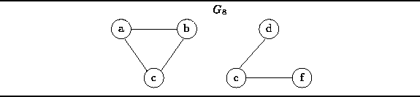
Figure: An Unconnected, Undirected Graph with Two (Connected) Components
A traversal of an undirected graph (either depth-first or breadth-first) starting from any vertex will only visit all the other vertices of the graph if that graph is connected. Therefore, there is a very simply way to test whether an undirected graph is connected: Count the number of vertices visited during a traversal of the graph. Only if all the vertices are visited is the graph connected.
Program shows how this can be implemented. The IsConnected member function of the Graph class is a Boolean-valued accessor that returns true if the graph is connected. The routine is implemented using a CountingVisitor and the DepthFirstTraversal routine.
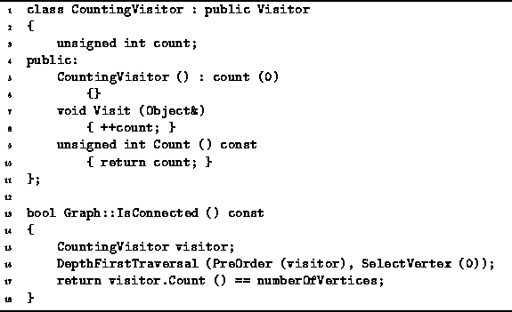
Program: Graph Class IsConnected Member Function Definition
A CountingVisitor is a visitor that simply counts the number of vertices it visits. It has a single member variable, count, which is initialized to zero in the constructor. The Visit routine adds one the count each time it is called and the Count accessor returns the value of the count.
The worst-case running time of the IsConnected routine is determined by the time taken by the DepthFirstTraversal. Clearly in this case . Therefore, the running time of IsConnected is when adjacency matrices are used to represent the graph and when adjacency lists are used.

Connectedness of a Directed Graph
When dealing with directed graphs, we define two kinds of connectedness, strong and weak. Strong connectedness of a directed graph is defined as follows:
Definition (Strong Connectedness of a Directed Graph) A directed graph is strongly connected if there is a path in G between every pair of vertices in .
For example, Figure shows the directed graph given by
Notice that the graph is not connected! E.g., there is no path from any of the vertices in to any of the vertices in . Nevertheless, the graph ``looks'' connected in the sense that it is not made of up of separate parts in the way that the graph in Figure is.
This idea of ``looking'' connected is what weak connectedness represents. To define weak connectedness we need to introduce first the notion of the undirected graph that underlies a directed graph: Consider a directed graph . The underlying undirected graph is the graph where represents the set of undirected edges that is obtained by removing the arrowheads from the directed edges in G:
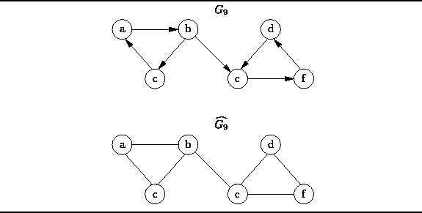
Figure: An Weakly Connected Directed Graph and the Underlying Undirected Graph
Weak connectedness of a directed graph is defined with respect to its underlying, undirected graph:
Definition (Weak Connectedness of a Directed Graph) A directed graph is weakly connected if the underlying undirected graph is connected.
For example, since the undirected graph in Figure is connected, the directed graph is weakly connected. Consider what happens when we remove the edge (b,e) from the directed graph . The underlying undirected graph that we get is in Figure . Therefore, when we remove edge (b,e) from , the graph that remains is neither strongly connected nor weakly connected.
A traversal of a directed graph (either depth-first or breadth-first) starting from a given vertex will only visit all the vertices of an undirected graph if there is a path from the start vertex to every other vertex. Therefore, a simple way to test whether a directed graph is strongly connected uses traversals--one starting from each vertex in . Each time the number of vertices visited is counted. The graph is strongly connected if all the vertices are visited in each traversal.
Program shows how this can be implemented. It shows the IsConnected member function of the Digraph class which returns the Boolean value true if the graph is strongly connected.
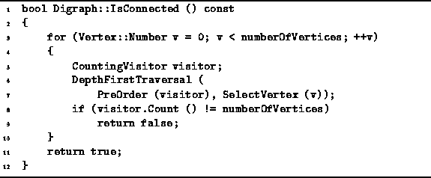
Program: Digraph Class IsConnected Member Function Definition
The routine consists of a loop over all the vertices of the graph. Each iteration does a DepthFirstTraversal using the CountingVisitor given in Program . The running time for one iteration is essentially that of the DepthOrderTraversal since for the counting visitor. Therefore, the worst-case running time for the IsConnected routine is when adjacency matrices are used and when adjacency lists are used to represent the graph.

Testing for Cycles in a Directed Graph
The final application of graph traversal that we consider in this section is to test a directed graph for cycles. An easy way to do this is to attempt a topological-order traversal using the algorithm given in Section . This algorithm only visits all the vertices of a directed graph if that graph contains no cycles.
To see why this is so, consider the directed cyclic graph shown in Figure . The topological traversal algorithm begins by computing the in-degrees of the vertices. (The number shown below each vertex in Figure is the in-degree of that vertex).
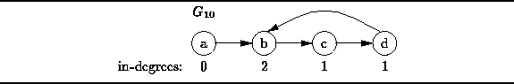
Figure: A Directed Cyclic Graph
At each step of the traversal, a vertex with in-degree of zero is visited. After a vertex is visited, the vertex and all the edges emanating from that vertex are removed from the graph. Notice that if we remove vertex a and edge (a,b) from , all the remaining vertices have in-degrees of one. The presence of the cycle prevents the topological-order traversal from completing.
Therefore, the a simple way to test whether a directed graph is cyclic is to attempt a topological traversal of its vertices. If all the vertices are not visited, the graph must be cyclic.
Program gives the implementation of the IsCyclic member function of the Digraph class. This Boolean-valued accessor returns true if the graph is cyclic. The implementation simply makes use of a CountingVisitor to count the number of vertices visited during a TopologicalOrderTraversal of the graph.

Shortest-Path Algorithms
In this section we consider edge-weighted graphs, both directed and undirected, in which the weight measures the cost of traversing that edge. The units of cost depend on the application.
For example, we can use a directed graph to represent a network of airports. In such a graph the vertices represent the airports and the edges correspond to the available flights between airports. In this scenario there are several possible cost metrics: If we are interested in computing travel time, then we use an edge-weighted graph in which the weights represent the flying time between airports. If we are concerned with the financial cost of a trip, then the weights on the edges represent the monetary cost of a ticket. Finally, if we are interested the actual distance traveled, then the weights represent the physical distances between airports.
If we are interested in traveling from point A to B, we can use a suitably labeled graph to answer the following questions: What is the fastest way to get from A to B? Which route from A to B has the least expensive airfare? What is the shortest possible distance traveled to get from A to B?
Each of these questions is an instance of the same problem: Given an edge-weighted graph, , and two vertices, and , find the path that starts at and ends at that has the smallest weighted path length. The weighted length of a path is defined as follows:
Definition (Weighted Path Length) Consider an edge-weighted graph . Let be the weight on the edge connecting to . A path in G is a non-empty sequence of vertices . The weighted path length of path P is given by
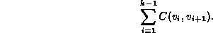
The weighted length of a path is the sum of the weights on the edges in that path. Conversely, the unweighted length of a path is simply the number of edges in that path. Therefore, the unweighted length of a path is equivalent to the weighted path length obtained when all edge weights are one.
- Single-Source Shortest Path
- All-Pairs Source Shortest Path

Single-Source Shortest Path
In this section we consider the single-source shortest path problem: Given an edge-weighted graph and a vertex , find the shortest weighted path from to every other vertex in .
Why do we find the shortest path to every other vertex if we are interested only in the shortest path from, say, to ? It turns out that in order to find the shortest path from to , it is necessary to find the shortest path from to every other vertex in G!
Clearly, when we search for the shortest path, we must consider all the vertices in . If a vertex is ignored, say , then we will not consider any of the paths from to that pass through . But if we fail to consider all the paths from to , we cannot be assured of finding the shortest one.
Furthermore, suppose the shortest path from to passes through some intermediate node . I.e., the shortest path is of the form It must be the case that the portion of P between to is also the shortest path from to . Suppose it is not. Then there exists another shorter path from to . But then, P would not be the shortest path from to , because we could obtain a shorter one by replacing the portion of P between and by the shorter path.
Consider the directed graph shown in Figure . The shortest weighted path between vertices b and f is the path which has the weighted path length nine. On the other hand, the shortest unweighted path is from b to f is the path of length three, .
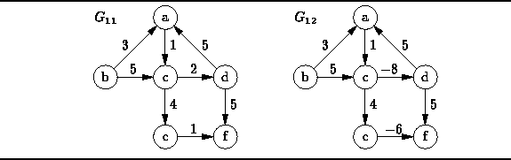
Figure: Two Edge-Weighted Directed Graphs
As long as all the edge weights are non-negative (as is the case for ), the shortest-path problem is well defined. Unfortunately, things get a little tricky in the presence of negative edge weights.
For example, consider the graph shown in Figure . Suppose we are looking for the shortest path from d to f. Exactly two edges emanate from vertex d, both with the same edge weight of five. If the graph contained only positive edge weights, there could be no shorter path than the direct path .
However, in a graph that contains negative weights, a long path gets ``shorter'' when we add edges with negative weights to it. E.g., the path has a total weighted path length of four, even though the first edge, (d,a), has the weight five.
But negative weights are even more insidious than this: For example, the path , which also joins vertex d to f, has a weighted path length of two but the path has length zero. I.e., as the number of edges in the path increases, the weighted path length decreases! The problem in this case is the existence of the cycle the weighted path length of which is less than zero. Such a cycle is sometimes called a negative cost cycle .
Clearly, the shortest-path problem is not defined for graphs that contain negative cost cycles. However, negative edges are not intrinsically bad. Solutions to the problem do exist for graphs that contain both positive and negative edge weights, as long as there are no negative cost cycles. Nevertheless, the problem is greatly simplified when all edges carry non-negative weights.
- Dijkstra's Algorithm
- Data Structures for Dijkstra's Algorithm
- Implementation
- Running Time Analysis

Dijkstra's Algorithm

Dijkstra's algorithm is a greedy algorithm for solving the single-source, shortest-path problem on an edge-weighted graph in which all the weights are non-negative. It finds the shortest paths from some initial vertex, say , to all the other vertices one-by-one. The essential feature of Dijkstra's algorithm is the order in which the paths are determined: The paths are discovered in the order of their weighted lengths, starting with the shortest, proceeding to the longest.
For each vertex v, Dijkstra's algorithm keeps track of three pieces of information, , , and :
The Boolean-valued flag indicates that the shortest path to vertex v is known. Initially, for all .
The quantity is the length of the shortest known path from to v. When the algorithm begins, no shortest paths are known. The distance is a tentative distance. During the course of the algorithm candidate paths are examined and the tentative distances are modified.
Initially, for all such that , while .
The predecessor of vertex v on the shortest path from to v. I.e., the shortest path from to v has the form .
Initially, is unknown for all .
Dijkstra's algorithm proceeds in phases. The following steps are performed in each pass:
- From the set of vertices for with , select the vertex v having the smallest tentative distance .
- Set .
- For each vertex w adjacent to v for which , test whether the tentative distance is greater than . If it is, set and set .
In each pass exactly one vertex has its set to true. The algorithm terminates after passes are completed at which time all the shortest paths are known.
Table illustrates the operation of Dijkstra's algorithm as it finds the shortest paths starting from vertex b in graph shown in Figure .

 | passes
vertex | initially |  |  |  |  | 1 |  |  |  |  | 2 |  |  |  |  | 3 |  |  |  |  | 4 |  |  |  |  | 5 |  |  |  |  | 6
a |  |  |  |  |  |  |  | 3 |  | b |  |  | 3 |  | b |  |  | 3 |  | b |  |  | 3 |  | b |  |  | 3 |  | b |  |  | 3 |  | b
b |  |  | 0 |  | -- |  |  | 0 |  | -- |  |  | 0 |  | -- |  |  | 0 |  | -- |  |  | 0 |  | -- |  |  | 0 |  | -- |  |  | 0 |  | --
c |  |  |  |  |  |  |  | 5 |  | b |  |  | 4 |  | a |  |  | 4 |  | a |  |  | 4 |  | a |  |  | 4 |  | a |  |  | 4 |  | a
d |  |  |  |  |  |  |  |  |  |  |  |  |  |  |  |  |  | 6 |  | c |  |  | 6 |  | c |  |  | 6 |  | c |  |  | 6 |  | c
e |  |  |  |  |  |  |  |  |  |  |  |  |  |  |  |  |  | 8 |  | c |  |  | 8 |  | c |  |  | 8 |  | c |  |  | 8 |  | c
f |  |  |  |  |  |  |  |  |  |  |  |  |  |  |  |  |  |  |  |  |  |  | 11 |  | d |  |  | 9 |  | e |  |  | 9 |  | e
Table: Operation of Dijkstra's Algorithm
Initially all the tentative distances are , except for vertex b which has tentative distance zero. Therefore, vertex b is selected in the first pass. The mark beside an entry in Table indicates that the shortest path is known ( ).
Next we follow the edges emanating from vertex b, and , and update the distances accordingly. The new tentative distances for a becomes 3 and the new tentative distance for c is 5. In both cases, the next-to-last vertex on the shortest path is vertex b.
In the second pass, vertex a is selected and its entry is marked with indicating the shortest path is known. There is one edge emanating from a, . The distance to c via a is 4. Since this is less than the tentative distance to c, vertex c is given the new tentative distance 4 and its predecessor on the shortest-path is set to a. The algorithm continues in this fashion for a total of passes until all the shortest paths have been found.
The shortest-path information contained in the right-most column of Table can be represented in the form of a vertex-weighted graph as shown in Figure .
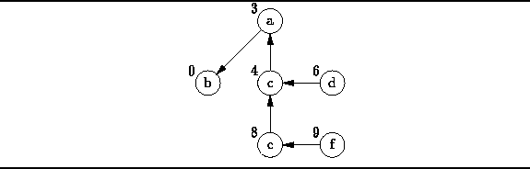
Figure: The Shortest-Path Graph for
This graph contains the same set of vertices as the problem graph . Each vertex v is labeled with the length of the shortest path from b to v. Each vertex (except b) has a single emanating edge that connects the vertex to the next-to-last vertex on the shortest-path. By following the edges in this graph from any vertex v to vertex b, we can construct the shortest path from b to v in reverse.

Data Structures for Dijkstra's Algorithm
The implementation of Dijkstra's algorithm described below uses the TableEntry structure declared in Program . Each TableEntry instance has three fields, known, distance and predecessor, which correspond to the variables , and , respectively.
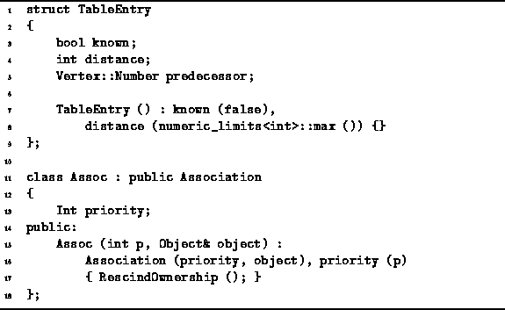
Program: Data Structures for Dijkstra's Algorithm
In each pass of its operation, Dijkstra's algorithm selects from the set of vertices for which the shortest-path is not yet known the one with the smallest tentative distance. Therefore, we use a priority queue to represent this set of vertices.
The priority assigned to a vertex is its tentative distance. The class Assoc defined in Program is used to associate of a priority with a given object instance. The Assoc class is derived from the Association class given in Section . Notice that the Assoc constructor calls RescindOwnership to prevent the destructor from deleting the associated object instance.

Implementation
A version of Dijkstra's algorithm is shown in Program . The DijkstrasAlgorithm function takes two arguments. The first is a const reference to a directed graph instance. It is assumed that the directed graph is an edge-weighted graph in which the weights are instances of the Int class defined in Program . The second argument is a const reference to the start node.
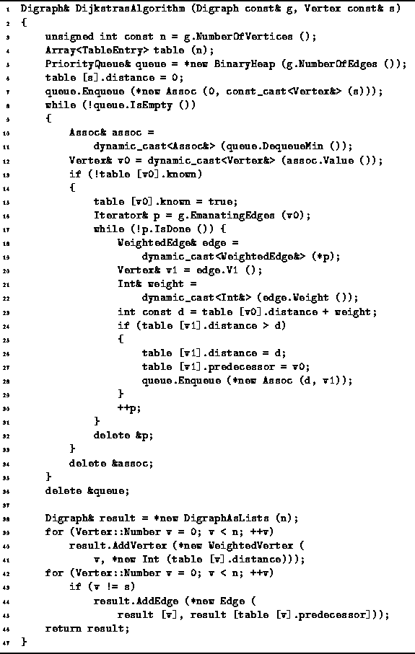
Program: Dijkstra's Algorithm
The DijkstrasAlgorithm routine returns its result in the form of a shortest-path graph. Therefore, the return value is a reference to a Digraph instance. The function allocates the storage, constructs the shortest-path graph and returns a reference to that graph.
The main data structures used are called table and queue (lines 4-5). The former is an array of TableEntry elements. The latter is a reference to a priority queue. In this case, a BinaryHeap of length is used. (See Section ).
The algorithm begins by setting the tentative distance for the start vertex to zero and inserting the start vertex into the priority queue with priority zero (lines 7-8).
The main loop of the routine comprises lines 8-35. In each iteration of this loop the vertex with the smallest distance is dequeued (lines 10-12). The vertex is processed only if its table entry indicates that the shortest path is not already known (line 13).
When a vertex v0 is processed, its shortest path is deemed to be known (line 15). Then each vertex v1 adjacent to vertex is considered (lines 16-19). The distance to v1 along the path that passes through v0 is computed (lines 20-23). If this distance is less than the tentative distance associated with v1, entries in the table for v1 are updated, and the v1 is given a new priority and inserted into the priority queue (lines 24-29).
The main loop terminates when all the shortest paths have been found. The shortest-path graph is then constructed using the information in the table (lines 38-45).

Running Time Analysis
The running time of the DijkstrasAlgorithm routine is dominated by the running time of the main loop (lines 8-35). (It is easy to see that lines 3-7 run in constant time, and lines 38-45 run in time).
To determine the running time of the main loop, we proceed as follows: First, we ignore temporarily the time required for the Enqueue and Dequeue operations in the priority queue. Clearly, each vertex in the graph is processed exactly once. When a vertex is processed all the edges emanating from it are considered. Therefore, the time (ignoring the priority queue operations) taken is O(|V|+|E|) when adjacency lists are used and when adjacency matrices are used.
Now, we add back the worst-case time required for the priority queue operations. In the worst case, a vertex is enqueued and subsequently dequeued once for every edge in the graph. Therefore, the length of the priority queue is at most . As a result, the worst-case time for each operation is .
Thus, the worst-case running time for Dijkstra's algorithm is
when adjacency lists are used, and
when adjacency matrices are used to represent the input graph.

All-Pairs Source Shortest Path
In this section we consider the all-pairs, shortest path problem: Given an edge-weighted graph , for each pair of vertices in find the length of the shortest weighted path between the two vertices.
One way to solve this problem is to run Dijkstra's algorithm times in turn using each vertex in as the initial vertex. Therefore, we can solve the all-pairs problem in time when adjacency lists are used, and , when adjacency matrices are used. However, for a dense graph ( ) the running time of Dijkstra's algorithm is , regardless of the representation scheme used.
- Floyd's Algorithm
- Implementation
- Running Time Analysis

Floyd's Algorithm
Floyd's algorithm uses the dynamic programming method to solve the all-pairs shortest-path problem on a dense graph. The method makes efficient use of an adjacency matrix to solve the problem. Consider an edge-weighted graph , where C(v,w) represents the weight on edge (v,w). Suppose the vertices are numbered from 1 to . I.e., let . Furthermore, let be the set comprised of the first k vertices in . I.e., , for .
Let be the shortest path from vertex v to w that passes only through vertices in , if such a path exists. I.e., the path has the form
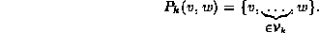
Let be the length of path :
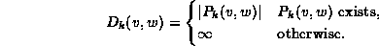
Since , the paths are correspond to the edges of G:
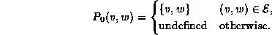
Therefore, the path lengths correspond to the weights on the edges of G:
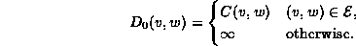
Floyd's algorithm computes the sequence of matrices . The distances in represent paths with intermediate vertices in . Since , we can obtain the distances in from those in by considering only the paths that pass through vertex . Figure illustrates how this is done.
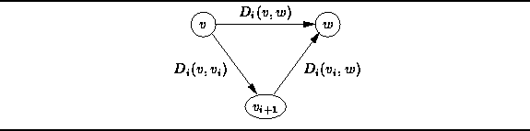
Figure: Calculating in Floyd's Algorithm
For every pair of vertices (v,w), we compare the distance , (which represents the shortest path from v to w that does not pass through ) with the sum (which represents the shortest path from v to w that does pass through ). Thus, is computed as follows:

Implementation
An implementation of Floyd's algorithm is shown in Program . The FloydsAlgorithm function takes as its lone argument a const reference to a directed graph instance. The directed graph is assumed to be an edge-weighted graph in which the weights are instances of the Int class defined in Program .
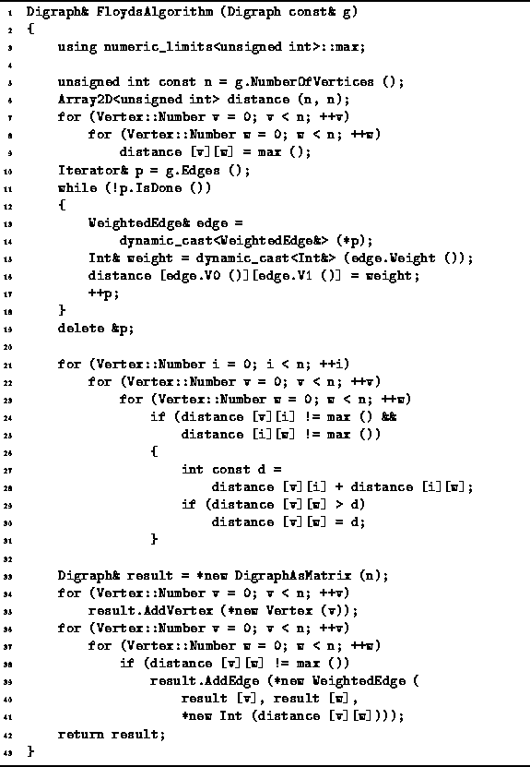
Program: Floyd's Algorithm
The FloydsAlgorithm routine returns its result in the form of an edge-weighted directed graph. Therefore, the return value is a reference to a Digraph instance. The function allocates the storage, constructs the graph and returns a reference to that graph.
The principal data structure use by the algorithm is a matrix of unsigned integers called distance. All the elements of the matrix are initially set to (lines 6-9). Next, an edge iterator is used to visit all the edges in the input graph in order to transfer the weights from the graph to the distance matrix (lines 10-19).
The main work of the algorithm is done in three, nested loops (lines 21-31). The outer loop computes the sequence of distance matrices . The inner two loops consider all possible pairs of vertices. Notice that as is computed, its entries overwrite those of .
Finally, the values in the distance matrix are transfered to the result graph. The result graph contains the same set of vertices as the input graph. For each finite entry in the distance matrix, a weighted edge is added to the result graph.

Running Time Analysis
The worst-case running time for Floyd's algorithm is easily determined. Creating and initializing the distance matrix is (lines 6-9). Transferring the weights from the input graph to the distance matrix requires time if adjacency lists are used, and time when an adjacency matrix is used to represent the input graph (lines 10-19).
The running time for the three nested loops is in the worst case. Finally, constructing the result graph and transferring the entries from the distance matrix to the result requires time. As a result, the worst-case running time of Floyd's algorithm is .

Minimum-Cost Spanning Trees
In this section we consider undirected graphs and their subgraphs. A subgraph of a graph is any graph such that and . In particular, we consider connected undirected graphs and their minimal subgraphs . The minimal subgraph of a connected graph is called a spanning tree:
Definition (Spanning Tree) Consider a connected, undirected graph . A spanning tree of G is a subgraph of G, say , with the following properties:
- .
- T is connected.
- T is acyclic.
Figure shows an undirected graph, , together with three of its spanning trees. A spanning tree is called a tree because every acyclic undirected graph can be viewed as a general, unordered tree. Because the edges are undirected, any vertex may be chosen to serve as the root of the tree. For example, the spanning tree of given in Figure (c) can be viewed as the general, unordered tree
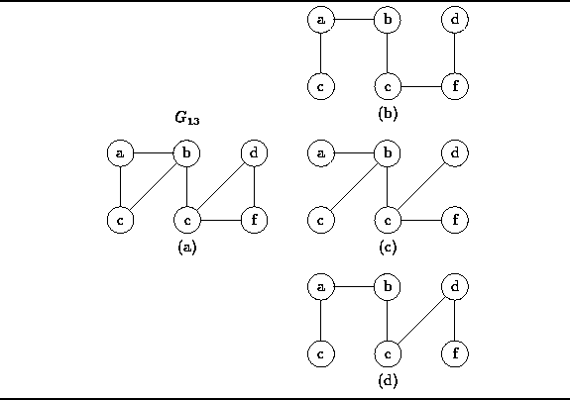
Figure: An Undirected Graph and Three Spanning Trees
According to Definition , a spanning tree is connected. Therefore, as long as the tree contains more than one vertex, there can be no vertex with degree zero. Furthermore, the following theorem guarantees that there is always at least one vertex with degree one:
Theorem Consider a connected, undirected graph , where . Let be a spanning tree of G. The spanning tree T contains at least one vertex of degree one.
extbfProof (By contradiction). Assume that there is no vertex in T of degree one. I.e., all the vertices in T have degree two or greater. Then by following edges into and out of vertices we can construct a path that is cyclic. But a spanning tree is acyclic--a contradiction. Therefore, a spanning tree always contains at least one vertex of degree one.
According to Definition , the edge set of a spanning tree is a subset of the edges in the spanned graph. How many edges must a spanning tree have? The following theorem answers the question:
Theorem Consider a connected, undirected graph . Let be a spanning tree of G. The number of edges in the spanning tree is given by
extbfProof (By induction). We can prove Theorem by induction on , the number of vertices in the graph.
Base Case Consider a graph that contains only one node, i.e., . Clearly, the spanning tree for such a graph contains no edges. Since , the theorem is valid.
Inductive Hypothesis Assume that the number of edges in a spanning tree for a graph with has been shown to be for .
Consider a graph with k+1 vertices and its spanning tree . According to Theorem , contains at least one vertex of degree one. Let be one such vertex and be the one edge emanating from v in .
Let be the graph of k nodes obtained by removing v and its emanating edge from the graph . I.e., .
Since is connected, so too is . Similarly, since is acyclic, so too is . Therefore is a spanning tree with k vertices. By the inductive hypothesis has k-1 edges. Thus, as k edges.
Therefore, by induction on k, the spanning tree for a graph with vertices contains edges.
- Constructing Spanning Trees
- Minimum-Cost Spanning Trees
- Prim's Algorithm
- Kruskal's Algorithm

Constructing Spanning Trees
Any traversal of a connected, undirected tree visits all the vertices in that tree, regardless of the node from which the traversal is started. During the traversal certain edges are traversed while the remaining edges are not. Specifically, an edge is traversed if it leads from a vertex that has been visited to a vertex that has not been visited. The set of edges which are traversed during a traversal forms a spanning tree.
The spanning tree obtained from a breadth-first traversal starting at vertex v of graph G is called the breadth-first spanning tree of G rooted at v. For example, the spanning tree shown in Figure (c) is the breadth-first spanning tree of rooted at vertex b.
Similarly, the spanning tree obtained from a depth-first traversal is the depth-first spanning tree of G rooted at v. The spanning tree shown in Figure (d) is the depth-first spanning tree of rooted at vertex c.

Minimum-Cost Spanning Trees
The total cost of an edge-weighted undirected graph is simply the sum of the weights on all the edges in that graph. A minimum-cost spanning tree of a graph is a spanning tree of that graph that has the least total cost:
Definition (Minimal Spanning Tree) Consider an edge-weighted, undirected, connected graph , where C(v,w) represents the weight on edge . The minimum spanning tree of G is the spanning tree that has the smallest total cost,
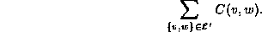
Figure shows edge-weighted graph together with its minimum-cost spanning tree . In general, it is possible for a graph to have several different minimum-cost spanning trees. However, in this case there is only one.
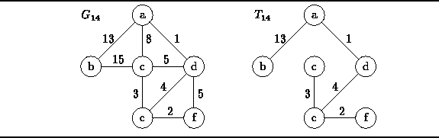
Figure: An Edge-Weighted, Undirected Graph and a Minimum-Cost Spanning Tree
The two sections that follow present two different algorithms for finding the minimum-cost spanning tree. Both algorithms are similar in that they build the tree one edge at a time.

Prim's Algorithm
Prim's algorithm finds a minimum-cost spanning tree of an edge-weighted, connected, undirected graph . The algorithm constructs the minimum-cost spanning tree of a graph by selecting edges from the graph one-by-one and adding those edges to the spanning tree.
Prim's algorithm is essentially a minor variation of Dijkstra's algorithm (see Section ). To construct the spanning tree, the algorithm constructs a sequence of spanning trees , each of which is a subgraph of G. The algorithm begins with a tree that contains one selected vertex, say . I.e., .
Given , we obtain the next tree in the sequence as follows. Consider the set of edges given by
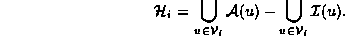
The set contains all the edges such that exactly one of v or w is in (but not both). Select the edge with the smallest edge weight,
Then , where and . After such steps we get which is the minimum-cost spanning tree of G.
Figure illustrates how Prim's algorithm determines the minimum-cost spanning tree of the graph shown in Figure . The circled vertices are the elements of , the solid edges represent the elements of and the dashed edges represent the elements of .
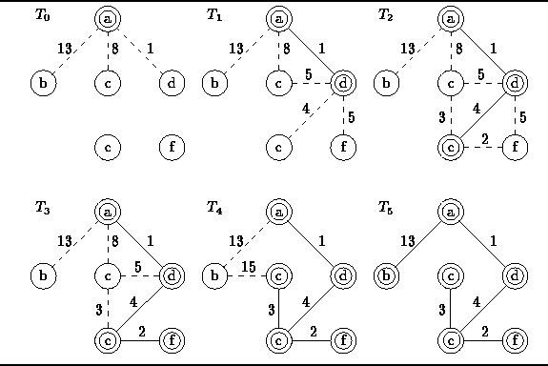
Figure: Operation of Prim's Algorithm
- Implementation

Implementation
An implementation of Prim's algorithm is shown in Program . This implementation is almost identical to the version of Dijkstra's algorithm given in Program . In fact, there are only four differences between the two algorithms. These are found on lines 1, 23, 38, and 40-41.
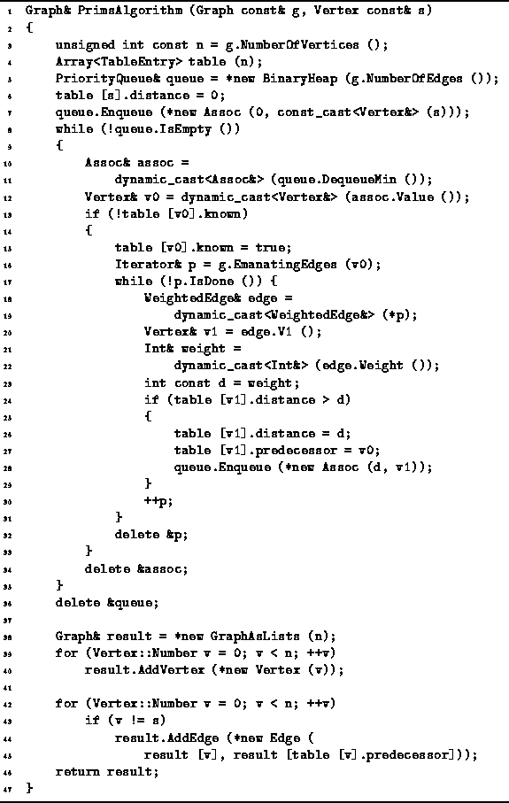
Program: Prim's Algorithm
The PrimsAlgorithm function takes two arguments. The first is a const reference to a undirected graph instance. We assume that the graph is edge-weighted and that the weights are instances of the Int class defined in Program . The second argument is a const reference to the start node.
The PrimsAlgorithm routine returns a minimum-cost spanning tree represented as an undirected graph. Therefore, the return value is a reference to a Graph instance. The function allocates the storage, constructs the spanning tree and returns a reference to that graph.
The running time of Prim's algorithm is asymptotically the same as Dijkstra's algorithm. I.e., the worst-case running time is
when adjacency lists are used, and
when adjacency matrices are used to represent the input graph.

Kruskal's Algorithm
Like Prim's algorithm, Kruskal's algorithm also constructs the minimum spanning tree of a graph by adding edges to the spanning tree one-by-one. At all points during its execution the set of edges selected by Prim's algorithm forms exactly one tree. On the other hand, the set of edges selected by Kruskal's algorithm forms a forest of trees.
Kruskal's algorithm is conceptually quite simple. The edges are selected and added to the spanning tree in increasing order of their weights. An edge is added to the tree only if it does not create a cycle.
The beauty of Kruskal's algorithm is the way that potential cycles are detected. Consider an undirected graph . We can view the set of vertices, , as a universal set and the set of edges, , as the definition of an equivalence relation over the universe . (See Definition ). In general, an equivalence relation partitions a universal set into a set of equivalence classes. If the graph is connected, there is only one equivalence class--all the elements of the universal set are equivalent. Therefore, a spanning tree is a minimal set of equivalences that result in a single equivalence class.
Kruskal's algorithm computes, , a sequence of partitions of the set of vertices . (Partitions are discussed in Section ). The initial partition consists of sets of size one:
Each subsequent element of the sequence is obtained from its predecessor by joining two of the elements of the partition. Therefore, has the form
for .
To construct the sequence the edges in are considered one-by-one in increasing order of their weights. Suppose we have computed the sequence up to and the next edge to be considered is . If v and w are both members of the same element of partition , then the edge forms a cycle, and is not part of the minimum-cost spanning tree.
On the other hand, suppose v and w are members of two different elements of partition , say and (respectively). Then must be an edge in the minimum-cost spanning tree. In this case, we compute by joining and . I.e., we replace and in by the union .
Figure illustrates how Kruskal's algorithm determines the minimum-cost spanning tree of the graph shown in Figure . The algorithm computes the following sequence of partitions:
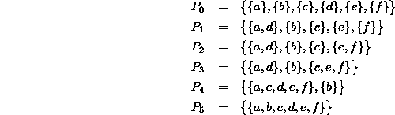
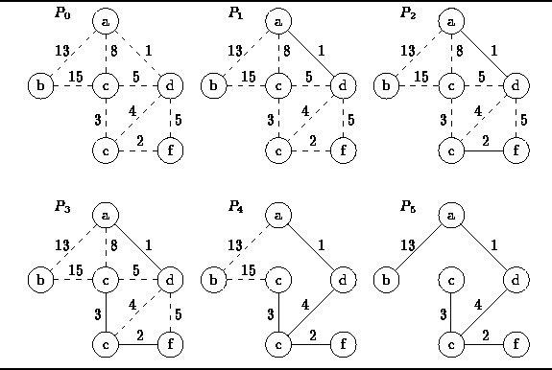
Figure: Operation of Kruskal's Algorithm
- Implementation
- Running Time Analysis

Implementation
An implementation of Kruskal's algorithm is shown in Program . The KruskalsAlgorithm function takes as its lone argument a const reference to an edge-weighted, undirected graph. This implementation assumes that the edge weights are instances of the Int class defined in Program . The routine computes the minimum-cost spanning tree and returns it in the form of an edge-weighted undirected graph. The function allocates the storage, constructs the graph and returns a reference to a Graph instance.
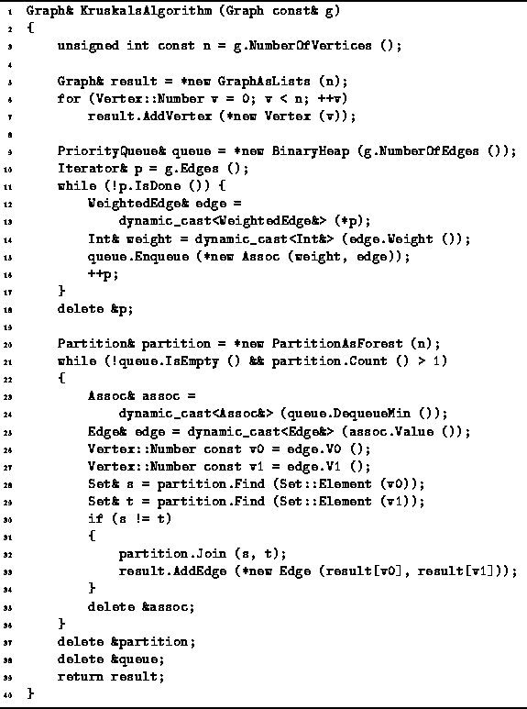
Program: Kruskal's Algorithm
The main data structures used by the routine are a priority queue to hold the edges, a partition to detect cycles and a graph for the result. This implementation uses a BinaryHeap (Section ) for the priority queue, a PartitionAsForest (Section ) for the partition and a GraphAsLists for the spanning tree.

Running Time Analysis
The KruskalsAlgorithm routine begins by creating an graph to hold the result spanning tree (lines 3-7). Since a spanning tree is a sparse graph the GraphAsLists class is used to represent it. Initially the graph contains vertices but no edges. The running time for lines 3-7 is .
Next all of the edges in the input graph are inserted one-by-one into the priority queue (lines 9-18). Since there are edges, the worst-case running time for a single insertion is . Therefore, the worst-case running time to initialize the priority queue is
when adjacency lists are used, and
when adjacency matrices are used to represent the input graph.
The main loop of the routine comprises lines 21-36. This loop is done at most times. In each iteration of the loop, one edge is removed from the priority queue (lines 23-25). In the worst-case this takes time.
Then, two partition find operations are done to determine the elements of the partition that contain the two end-points of the given edge (lines 26-29). Since the partition contains at most elements, the running time for the find operations is . If the two elements of the partition are distinct, then an edge is added to the spanning tree and a join operation is done to unite the two elements of the partition (lines 30-34). The join operation also requires time in the worst-case. Therefore, the total running time for the main loop is .
Thus, the worst-case running time for Kruskal's algorithm is
when adjacency lists are used, and
when adjacency matrices are used to represent the input graph.

Application: Critical Path Analysis
In the introduction to this chapter it is stated that there are myriad applications of graphs. In this section we consider one such application--critical path analysis . Critical path analysis crops up in a number of different contexts, from the planning of construction projects to the analysis of combinational logic circuits.
For example, consider the scheduling of activities required to construct a building. Before the foundation can be poured, it is necessary to dig a hole in the ground. After the building has been framed, the electricians and the plumbers can rough-in the electrical and water services and this rough-in must be completed before the insulation is put up and the walls are closed in.
We can represent the set of activities and the scheduling constraints using a vertex-weighted, directed acyclic graph (DAG). Each vertex represents an activity and the weight on the vertex represents the time required to complete the activity. The directed edges represent the sequencing constraints. I.e., an edge from vertex v to vertex w indicates that activity v must complete before w may begin. Clearly, such a graph must be acyclic.
A graph in which the vertices represent activities is called an activity-node graph . Figure shows an example of of an activity-node graph. In such a graph it is understood that independent activities may proceed in parallel. For example, after activity A is completed, activities B and C may proceed in parallel. However, activity D cannot begin until both B and C are done.
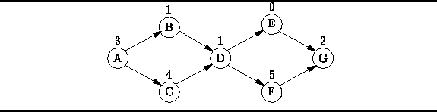
Figure: An Activity-Node Graph
Critical path analysis answers the following questions:
- What is the minimum amount of time needed to complete all activities?
- For a given activity v, is it possible to delay the completion of that activity without affecting the overall completion time? If yes, by how much can the completion of activity v be delayed?
The activity-node graph is a vertex-weighted graph. However, the algorithms presented in the preceding sections all require edge-weighted graphs. Therefore, we must convert the vertex-weighted graph into its edge-weighted dual . In the dual graph the edges represent the activities, and the vertices represent the commencement and termination of activities. For this reason, the dual graph is called an event-node graph .
Figure shows the event-node graph corresponding to the activity node graph given in Figure . Where an activity depends on more than one predecessor it is necessary to insert dummy edges.
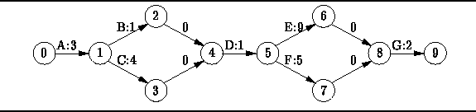
Figure: The Event-Node Graph corresponding to Figure
For example, activity D cannot commence until both B and C are finished. In the event-node graph vertex 2 represents the termination of activity B and vertex 3 represents the termination of activity C. It is necessary to introduce vertex 4 to represent the event that both B and C have completed. Edges and represent this synchronization constraint. Since these edges do not represent activities, the edge weights are zero.
For each vertex v in the event node graph we define two times. The first is the earliest event time for event v. It is the earliest time at which event v can occur assuming the first event begins at time zero. The earliest event time is given by
where is the initial event, is the set of incident edges on vertex w and C(v,w) is the weight on vertex (v,w).
Similarly, is the latest event time for event v. It is the latest time at which event v can occur The latest event time is given by
where is the final event.
Given the earliest and latest event times for all events, we can compute time available for each activity. E.g., consider an activity represented by edge (v,w). The amount of time available for the activity is and the time required for that activity is C(v,w). We define the slack time for an activity as the amount of time by which an activity can be delayed with affecting the overall completion time of the project. The slack time for the activity represented by edge (v,w) is given by
Activities with zero slack are critical . I.e., critical activities must be completed on time--any delay affects the overall completion time. A critical path is a path in the event-node graph from the initial vertex to the final vertex comprised solely of critical activities.
Table gives the results from obtained from the critical path analysis of the activity-node graph shown in Figure . The tabulated results indicate the critical path is
activity | C(v,w) |  |  | S(v,w)
A | 3 | 0 | 3 | 0
B | 1 | 3 | 7 | 3
C | 4 | 3 | 7 | 0
D | 1 | 7 | 8 | 0
E | 9 | 8 | 17 | 0
F | 5 | 8 | 17 | 4
G | 2 | 17 | 18 | 0
Table: Critical Path Analysis Results for the Activity-Node Graph in Figure
- Implementation

Implementation
Given an activity-node graph, the objective of critical path analysis is to determine the slack time for each activity and thereby to identify the critical activities and the critical path. We shall assume that the activity node graph has already been transformed to an edge-node graph. The implementation of this transformation is left as a project for the reader (Project ). Therefore, the first step is to compute the earliest and latest event times.
According to Equation , the earliest event time of vertex w is obtained from the earliest event times of all its predecessors. Therefore, must compute the earliest event times in topological order. To do this, we define the EarliestTimeVisitor shown in Program .
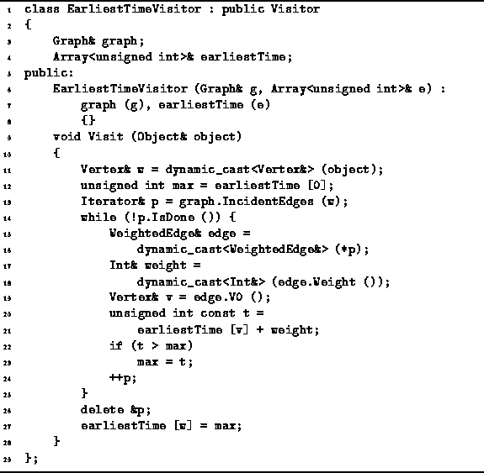
Program: Critical Path Analysis--Computing Earliest Event Times
The EarliestTimeVisitor has three member variables--graph, earliestTime and startTime. The first is a reference to the event-node graph; the second refers to an array used to record the values; and the third is the time at which the initial activity starts.
The Visit member function of the EarliestTimeVisitor class implements directly Equation . It uses an IncidentEdges iterator to determine all the predecessors of a given node and computes .
In order to compute the latest event times, it is necessary to define also a LatestTimeVisitor. This visitor must visit the vertices of the event-node graph in reverse topological order. Its implementation follows directly from Equation and Program .
Program defines the routine called CriticalPathAnalysis that does what its name implies. This routine takes as its lone argument a reference to a Digraph instance that represents an event-node graph. This implementation assumes that the edge weights are instances of the Int class defined in Program .
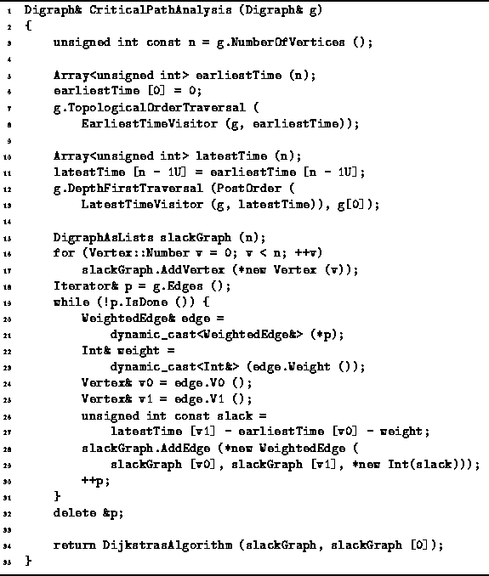
Program: Critical Path Analysis--Finding the Critical Paths
The routine first uses the EarliestTimeVisitor in a topological order traversal to compute the earliest event times which are recored in the earliestTime array (lines 5-8). Next, the latest event times are computed and recorded in the latestTime array. Notice that this is done using a LatestTimeVisitor in a postorder depth-first traversal (lines 10-13). This is because a postorder depth-first traversal is equivalent to a topological order traversal in reverse!
Once the earliest and latest event times have been found, we can compute the slack time for each edge. In the implementation shown, an edge-weighted graph is constructed that is isomorphic with the the original event-node graph, but in which the edge weights are the slack times as given by Equation (lines 15-31). By constructing such a graph we can make use of Dijkstra's algorithm find the shortest path from start to finish since the shortest path must be the critical path (line 34).
The DijkstrasAlgorithm routine given in Section returns its result in the form of a shortest-path graph. The shortest-path graph for the activity-node graph of Figure is shown in Figure . By following the path in this graph from vertex 9 back to vertex 0, we find that the critical path is .
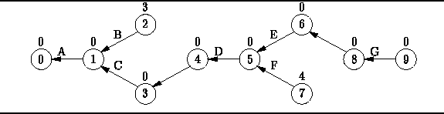
Figure: The Critical Path Graph corresponding to Figure

Exercises
- Consider the undirected graph shown in Figure . List the elements of and . Then, for each vertex do the following:
  - Compute the in-degree of v.
  - Compute the out-degree of v.
  - List the elements of .
  - List the elements of .
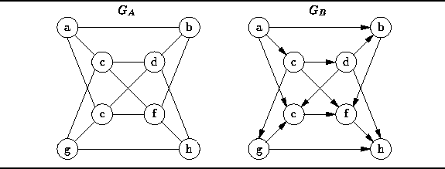
Figure: Sample Graphs
- Consider the directed graph shown in Figure .
  - Show how the graph is represented using an adjacency matrix.
  - Show how the graph is represented using adjacency lists.
- Repeat Exercises and for the directed graph shown in Figure .
- Consider a depth-first traversal of the undirected graph shown in Figure starting from vertex a.
  - List the order in which the nodes are visited in a preorder traversal.
  - List the order in which the nodes are visited in a postorder traversal.
Repeat this exercise for a depth-first traversal starting from vertex d.
- List the order in which the nodes of the undirected graph shown in Figure are visited by a breadth-first traversal that starts from vertex a. Repeat this exercise for a breadth-first traversal starting from vertex d.
- Repeat Exercises and for the directed graph shown in Figure .
- List the order in which the nodes of the directed graph shown in Figure are visited by a topological order traversal that starts from vertex a.
- Consider an undirected graph . If we use a adjacency matrix A to represent the graph, we end up using twice as much space as we need because A contains redundant information. I.e., A is symmetric about the diagonal and all the diagonal entries are zero. Show how a one-dimensional array of length can be used to represent G. Hint: consider just the part of A above the diagonal.
- What is the relationship between the sum of the degrees of the vertices of a graph and the number of edges in the graph.
- A graph with the maximum number of edges is called a fully connected graph . Draw fully connected, undirected graphs that contain 2, 3, 4 and 5 vertices.
- Prove that an undirected graph with n vertices contains at most n(n-1)/2 edges.
- Every tree is a directed, acyclic graph (DAG), but there exist DAGs that are not trees.
  - How can we tell whether a given DAG is a tree?
  - Devise an algorithm to test whether a given DAG is a tree.
- Consider an acyclic, connected, undirected graph G that has n vertices. How many edges does G have?
- In general, an undirected graph contains one or more connected components . A connected component of a graph G is a subgraph of G that is connected and contains the largest possible number of vertices. Each vertex of G is a member of exactly one connected component of G.
  - Devise an algorithm to count the number of connected components in a graph.
  - Devise an algorithm that labels the vertices of a graph in such a way that all the vertices in a given connected component get the same label and vertices in different connected components get different labels.
- A source in an directed graph is a vertex with zero in-degree. Prove that every DAG has at least one source.
- What kind of DAG has a unique topological sort?
- Under what conditions does a postorder depth-first traversal of a DAG visit the vertices in reverse topological order.
- Consider a pair of vertices, v and w, in a directed graph. Vertex w is said to be reachable from vertex v if there exists a path in G from v to w. Devise an algorithm that takes as input a graph, , and a pair of vertices, , and determines whether w is reachable from v.
- An Eulerian walk is a path in an undirected graph that starts and ends at the same vertex and traverses every edge in the graph. Prove that in order for such a path to exist, all the nodes must have even degree.
- Consider the binary relation defined for the elements of the set as follows:
How can we determine whether is a total order?
- Show how the single-source shortest path problem can be solved on a DAG using a topological-order traversal. What is the running time of your algorithm?
- Consider the directed graph shown in Figure . Trace the execution of Dijkstra's algorithm as it solves the single-source shortest path problem starting from vertex a. Give your answer in a form similar to Table .
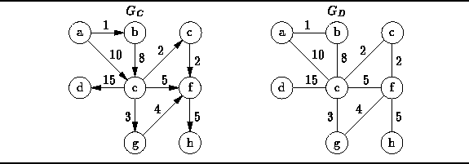
Figure: Sample Weighted Graphs
- Dijkstra's algorithm works as long as there are no negative edge weights. Given a graph that contains negative edge weights, we might be tempted to eliminate the negative weights by adding a constant weight to all of the edge weights to make them all positive. Explain why this does not work.
- Dijkstra's algorithm can be modified to deal with negative edge weights (but not negative cost cycles) by eliminating the known flag and by inserting a vertex back into the queue every time its tentative distance decreases. Explain why the modified algorithm works correctly. What is the running time of the modified algorithm?
- Consider the directed graph shown in Figure . Trace the execution of Floyd's algorithm as it solves the all-pairs shortest path problem.
- Prove that if the edge weights on an undirected graph are distinct, there is only one minimum-cost spanning tree.
- Consider the undirected graph shown in Figure . Trace the execution of Prim's algorithm as it finds the minimum-cost spanning tree starting from vertex a.
- Repeat Exercise using Kruskal's algorithm.
- Do Exercise .

Projects
- Devise a graph description language. Implement a routine that reads the description of a graph and constructs a graph object instance. Your routine should be completely generic--it should not depend on the graph implementation used.
- Extend Project by writing a routine that prints the description of a given graph object instance.
- Complete the implementation of the GraphAsMatrix class declared in Program by providing suitable definitions for the following member functions: GraphAsMatrix (constructor), GraphAsMatrix (destructor), Purge, AddVertex, SelectVertex, AddEdge, SelectEdge, IsEdge, Vertices, Edges, IncidentEdges and EmanatingEdges. Write a test program and test your implementation.
- Repeat Project for the GraphAsLists class.
- The DigraphAsMatrix class can be implemented using multiple inheritance:
- class DigraphAsMatrix : public Digraph, public GraphAsMatrix
- {
- ...
};
Implement the DigraphAsMatrix class by providing suitable definitions for the following member functions: DigraphAsMatrix (constructor), DigraphAsMatrix (destructor), Purge, AddEdge, SelectEdge, IsEdge and Edges. You must also have a complete implementation of the base class GraphAsMatrix (see Project ). Write a test program and test your implementation.
- Repeat Project for the DigraphAsLists class.
- Add a member function to the Digraph class abstract interface that creates an instance of and returns a reference to an undirected graph which underlies the given digraph.
- Devise an approach using an iterator and a stack to perform a topological-order traversal by doing a postorder depth-first traversal in reverse.
- The single-source shortest path problem on a DAG can be solved by visiting the vertices in topological order. Write an visitor for use with the TopologicalOrderTraversal routine that solves the single-source shortest path problem on a DAG.
- Devise and implement an routine that transforms a vertex-weighted activity-node graph into an edge-weighted event-node graph.
- Complete the implementation of the critical path analysis routines. In particular, you must implement the LatestTimeVisitor along the lines of the EarliestTimeVisitor defined in Program .

